IP Hash

📌 What Is IP Hash in Load Balancing?
# Source: AI Source: Provided by: [Data Path: Persons Table -> ID Column: 1, Name_En Column: Motasem Essam] -> From: [ChatGPT] on [12/15/2025]
IP Hash is a load balancing method where the client’s IP address is used to determine which server will handle the request. This ensures that the same user is consistently routed to the same server — unless the server list changes.

✅ Simple Definition:
# Source: AI Source: Provided by: [Data Path: Persons Table -> ID Column: 1, Name_En Column: Motasem Essam] -> From: [ChatGPT] on [12/15/2025]
IP Hash uses the client's IP address to pick a backend server.
This helps keep the user's requests "sticky" to one server.

🧠 Real-Life Analogy:
# Source: AI Source: Provided by: [Data Path: Persons Table -> ID Column: 1, Name_En Column: Motasem Essam] -> From: [ChatGPT] on [12/15/2025]
Imagine a restaurant where customers are seated based on the last digit of their phone number.
So, every time you come back, they seat you at the same table — that's what IP Hash does with traffic.

🧪 How IP Hash Works:
# Source: AI Source: Provided by: [Data Path: Persons Table -> ID Column: 1, Name_En Column: Motasem Essam] -> From: [ChatGPT] on [12/15/2025]
- The load balancer takes the client's IP address
- It applies a hashing algorithm to it
- Based on the result, it selects a server from the list
So if a user comes from IP 192.168.1.42, they might always go to Server B.

🧱 Nginx Example Configuration:
# Source: AI Source: Provided by: [Data Path: Persons Table -> ID Column: 1, Name_En Column: Motasem Essam] -> From: [ChatGPT] on [12/15/2025]
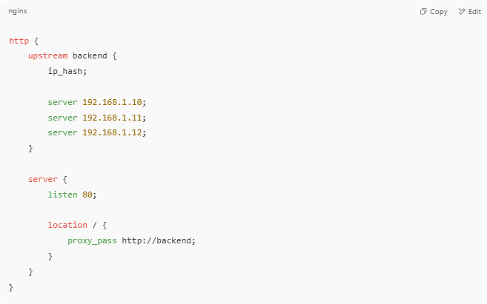

http {
upstream backend {
ip_hash;

server 192.168.1.10;
server 192.168.1.11;
server 192.168.1.12;
}

server {
listen 80;

location / {
proxy_pass http://backend;
}
}
}

✅ Result: Same IP address = same server (as long as the server list stays the same)

📈 Benefits of IP Hash
# Source: AI Source: Provided by: [Data Path: Persons Table -> ID Column: 1, Name_En Column: Motasem Essam] -> From: [ChatGPT] on [12/15/2025]
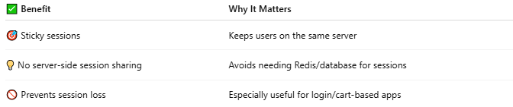

✅ Benefit | Why It Matters
🎯 Sticky sessions | Keeps users on the same server
💡 No server-side session sharing | Avoids needing Redis/database for sessions
🚫 Prevents session loss | Especially useful for login/cart-based apps

⚠️ Limitations
# Source: AI Source: Provided by: [Data Path: Persons Table -> ID Column: 1, Name_En Column: Motasem Essam] -> From: [ChatGPT] on [12/15/2025]


❌ Limitation | Description
❌ Not perfectly balanced | Some IPs may all hash to the same server
🔄 Server list change breaks mapping | Changing servers resets client-server pairings
🚫 Doesn’t work with NAT well | Clients behind NAT may all share 1 IP

🔁 When to Use IP Hash
# Source: AI Source: Provided by: [Data Path: Persons Table -> ID Column: 1, Name_En Column: Motasem Essam] -> From: [ChatGPT] on [12/15/2025]
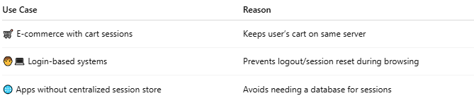

Use Case | Reason
🛒 E-commerce with cart sessions | Keeps user’s cart on same server
🧑‍💻 Login-based systems | Prevents logout/session reset during browsing
🌐 Apps without centralized session store | Avoids needing a database for sessions

🆚 Compare to Other Load Balancers
# Source: AI Source: Provided by: [Data Path: Persons Table -> ID Column: 1, Name_En Column: Motasem Essam] -> From: [ChatGPT] on [12/15/2025]
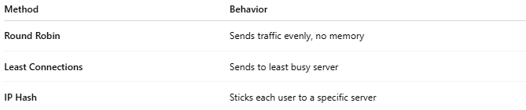

Method | Behavior
Round Robin | Sends traffic evenly, no memory
Least Connections | Sends to least busy server
IP Hash | Sticks each user to a specific server

📌 Summary
# Source: AI Source: Provided by: [Data Path: Persons Table -> ID Column: 1, Name_En Column: Motasem Essam] -> From: [ChatGPT] on [12/15/2025]
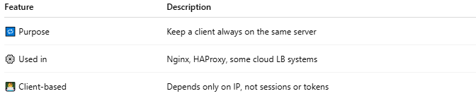

Feature | Description
🔁 Purpose | Keep a client always on the same server
⚙️ Used in | Nginx, HAProxy, some cloud LB systems
👨‍💻 Client-based | Depends only on IP, not sessions or tokens

